Name:- ramani harshil sureshbhai

**Module -1: Understanding of Hardware and Its Components**

**Section 1: Multiple Choice**

**1. Which of the following is NOT a component of the CPU?**

1. ALU

2. RAM

3. CU

4. 1 and 3 both

**Ans => 2. RAM**

**2. What is the function of RAM in a computer?**

**Ans => Ram is the temporary stores data and program use the ram for speed**

**3. Which of the following is a primary storage device?**

1. HDD

2. SSD

3. SD card

4. 1 and 2 both

**Ans => 4. 1 and 2 both**

**4. What is the purpose of a GPU?**

**Ans => The GPU use of the rendering of images and videos, and work smoothly**

**Section 2: True or False**

**5. The motherboard is the main circuit board of a computer where other components are attached.**

**Ans => True**

**6. A UPS (Uninterruptible Power Supply) is a hardware device that provides emergency power to a load when the input power source fails.**

**Ans => True**

**7. : An expansion card is a circuit board that enhances the functionality of a component.**

**Ans => True**

**Section 3: Short Answer**

**8. Explain the difference between HDD and SSD.**

**Ans =>** HDD (Hard Disk Drive) uses spinning disks to read/write data, offering large storage capacity at a lower cost but slower speed. SSD (Solid State Drive) uses flash memory to store data, providing faster read/write speeds, better durability, and lower power consumption but at a higher cost per gigabyte.

**9. Describe the function of BIOS in a computer system.**

**Ans =>** The BIOS (Basic Input/Output System) is firmware that initializes and tests hardware components during the computer's boot process. It provides a set of low-level routines that the operating system and other software use to interface with the hardware. The BIOS also manages system settings and boot order, and it loads the operating system into memory from a bootable device.

**10. List and briefly explain three input devices commonly used with computers.**

1. **Ans => Keyboard**: A device with keys for typing text, numbers, and commands into a computer. It allows users to input data and interact with software through alphanumeric and special function keys.
2. **Mouse**: A pointing device that detects two-dimensional motion relative to a surface. It typically has buttons and a scroll wheel, allowing users to interact with the graphical user interface by moving a pointer and selecting items on the screen.
3. **Scanner**: A device that captures images or text from physical documents and converts them into digital format. It is commonly used for digitizing photos, documents, and other printed media for storage, editing, and sharing on a computer.

**Section 4: Practical Application**

11. Identify and label the following components on a diagram of a motherboard:

● CPU ● RAM slots ● SATA connectors ● PCI-E slot

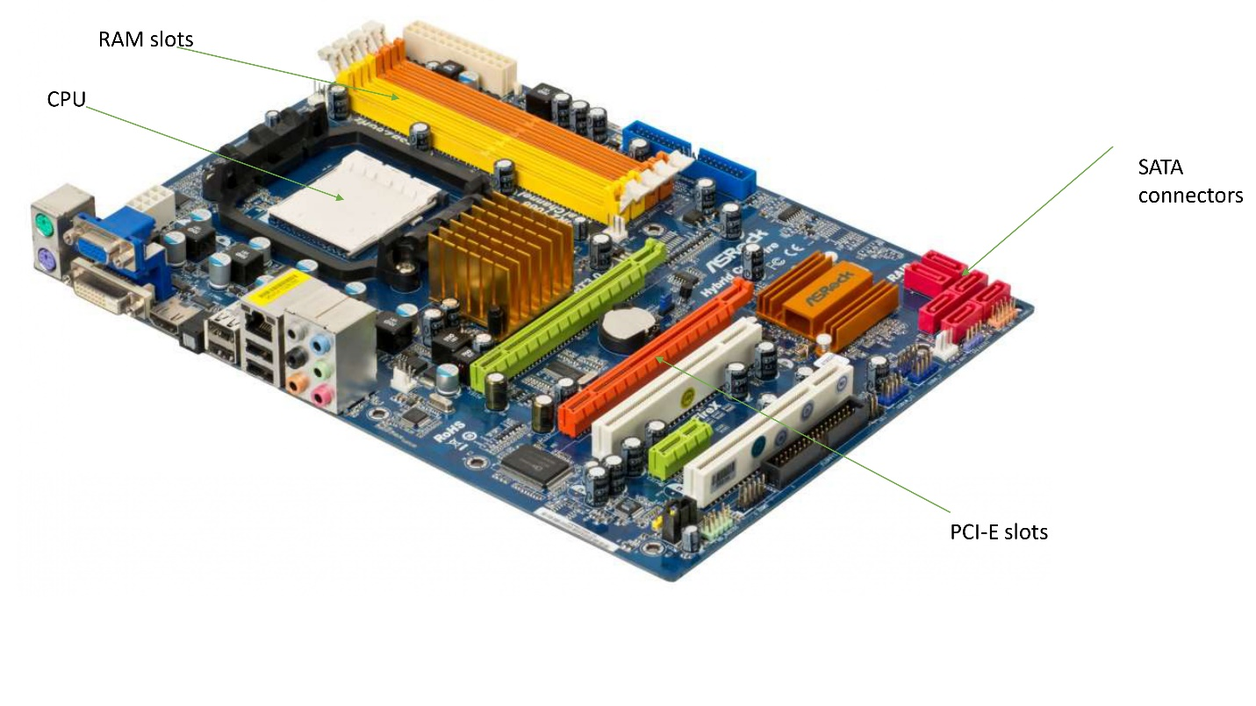

**12. Demonstrate how to install a RAM module into a computer.**

• **Power Down and Unplug**: Turn off the computer and unplug all cables, including the power cord, to ensure safety.

• **Open the Case**: Remove the screws or clips holding the side panel of the computer case in place, then slide or lift the panel off to expose the internal components.

• **Locate the RAM Slots**: Identify the RAM slots on the motherboard. These are long slots, typically located near the CPU.

• **Prepare the RAM Module**: If necessary, remove any existing RAM modules by pressing down on the clips at either end of the slot, which will cause the module to pop up slightly. Then, gently pull it out.

• **Align the RAM Module**: Take the new RAM module and align the notch on the module with the key in the slot. The module should only fit one way, ensuring correct orientation.

• **Insert the RAM Module**: Insert the RAM module into the slot at a slight angle and apply even pressure on both ends of the module until it clicks into place. The clips on the sides should snap back into position, securing the module.

• **Close the Case**: Replace the side panel of the computer case and secure it with screws or clips.

• **Reconnect and Power Up**: Reconnect all cables and power on the computer. The system should recognize the new RAM automatically. You can verify the installation by checking the system properties or BIOS to ensure the correct amount of RAM is detected.

**Section 5: Essay**

13. Discuss the importance of proper cooling mechanisms in a computer system. Include examples of cooling methods and their effectiveness.

**Ans =>** Proper cooling mechanisms are crucial for maintaining the performance, stability, and longevity of a computer system. As computers perform various tasks, their components, especially the CPU and GPU, generate significant amounts of heat. If this heat is not effectively dissipated, it can lead to overheating, resulting in system instability, reduced performance, and even permanent damage to hardware components.

**Importance of Cooling**

1. **System Stability and Performance**: Overheating can cause system crashes, freezes, and unexpected shutdowns. Adequate cooling ensures that the computer operates smoothly, maintaining optimal performance even under heavy loads.
2. **Component Longevity**: Prolonged exposure to high temperatures can degrade electronic components, shortening their lifespan. Effective cooling helps preserve the integrity of these components, ensuring they last longer.
3. **Preventing Thermal Throttling**: Modern CPUs and GPUs come with thermal throttling features that reduce their performance to prevent overheating. Proper cooling prevents the need for throttling, allowing the system to perform at its best.
4. **Safety**: Excessive heat can pose a fire hazard, especially if there are flammable materials nearby. Effective cooling reduces this risk, ensuring a safer operating environment.

**Cooling Methods**

1. **Air Cooling**: This is the most common cooling method, utilizing fans and heat sinks to dissipate heat. Heat sinks are metal structures attached to heat-generating components, increasing the surface area for heat dissipation. Fans then blow air over the heat sinks, carrying the heat away from the components. Air cooling is cost-effective and easy to install, making it suitable for most desktop computers and laptops. However, its effectiveness is limited by the ambient temperature and airflow within the case.
2. **Liquid Cooling**: Liquid cooling systems use a liquid coolant to absorb heat from components. The heated liquid is then pumped to a radiator, where fans dissipate the heat into the air. Liquid cooling is more efficient than air cooling, making it ideal for high-performance systems and overclocked CPUs or GPUs. It operates quietly and can manage higher heat loads, but it is more complex to install and maintain. Additionally, there is a risk of leaks, which can damage hardware components.
3. **Passive Cooling**: Passive cooling relies on heat sinks and natural convection without the use of fans or moving parts. It is silent and requires no power, making it suitable for low-power devices like smartphones, tablets, and some small form-factor PCs. However, passive cooling is generally less effective for high-performance components that generate significant heat.
4. **Thermoelectric Cooling**: This method uses Peltier devices, which create a temperature difference when an electric current passes through them. One side of the device absorbs heat and becomes cold, while the other side dissipates heat. Thermoelectric cooling can achieve very low temperatures but is less efficient and consumes more power than other methods. It is typically used in specialized applications where precise temperature control is necessary.

**Effectiveness of Cooling Methods**

The effectiveness of a cooling method depends on the system's requirements and the ambient conditions. Air cooling is sufficient for most standard consumer desktops and laptops, providing a good balance between cost and performance. Liquid cooling is preferred for high-performance systems and gaming rigs due to its superior heat dissipation capabilities and quiet operation. Passive cooling is effective for low-power devices but unsuitable for high-performance applications. Thermoelectric cooling offers precise control but at a higher cost and power consumption.

In conclusion, proper cooling mechanisms are essential for the optimal functioning of a computer system. By preventing overheating, they ensure system stability, enhance performance, prolong component lifespan, and maintain safety. Choosing the appropriate cooling method depends on the specific needs and constraints of the system, with each method offering distinct advantages and limitations.

**14. Explain the concept of bus width and its significance in computer architecture.**

**Ans =>** The concept of bus width is fundamental to understanding computer architecture. It refers to the number of bits that can be transmitted simultaneously over a computer bus, which is a communication system that transfers data between components inside or between computers. The bus width is a critical parameter because it directly affects the system's data transfer rate and overall performance.

**What is Bus Width?**

A bus in a computer system connects different components such as the CPU, memory, and input/output devices, allowing them to communicate with each other. The bus width is the number of parallel lines (or bits) that make up the bus. For instance, a bus width of 32 bits means that 32 bits of data can be transmitted simultaneously. Buses can be categorized into three main types: data bus, address bus, and control bus.

1. **Data Bus**: This bus carries the actual data being processed by the computer. The width of the data bus determines how much data can be transferred at one time. For example, a 32-bit data bus can transfer 32 bits of data simultaneously.
2. **Address Bus**: This bus carries the addresses of where data needs to be sent or retrieved from. The width of the address bus determines the maximum addressable memory space. For example, a 32-bit address bus can address 2^32 memory locations, which equals 4 gigabytes of addressable memory.
3. **Control Bus**: This bus carries control signals that manage the operations of the computer, such as read or write signals. The width of the control bus varies depending on the specific needs of the system.

**Significance of Bus Width**

1. **Data Transfer Rate**: The bus width is directly proportional to the data transfer rate of the system. A wider data bus can transfer more bits per clock cycle, thereby increasing the amount of data that can be moved between components in a given period. For example, upgrading from a 32-bit to a 64-bit data bus can theoretically double the data transfer rate, significantly enhancing performance.
2. **Memory Addressing**: The width of the address bus determines the maximum amount of memory that the system can address. With a wider address bus, a computer can access a larger memory space. This is crucial for applications that require large amounts of memory, such as databases, scientific computations, and high-end gaming.
3. **System Performance**: A wider bus can improve overall system performance by reducing bottlenecks. When the bus width matches the word size of the CPU (e.g., 32-bit or 64-bit), the system can fetch, process, and store data more efficiently. This alignment ensures that data is handled in chunks that are optimal for the CPU, minimizing delays caused by multiple data transfers.
4. **Compatibility and Future-Proofing**: Having a wider bus can enhance compatibility with future technologies. As software and applications continue to evolve, they often require more bandwidth and memory. Systems with wider buses are better equipped to handle these demands, extending their useful lifespan and reducing the need for frequent upgrades.
5. **Power Consumption and Cost**: While wider buses can improve performance, they also come with increased power consumption and cost. More lines mean more transistors, which require more power and generate more heat. Additionally, the complexity of designing and manufacturing wider buses increases the overall cost of the system. Therefore, there is a trade-off between performance gains and the associated costs and power requirements.

**Real-World Examples**

1. **Early Personal Computers**: Early personal computers typically had 8-bit or 16-bit buses. These limited bus widths restricted data transfer rates and memory addressing capabilities, making them suitable only for simple tasks and applications.
2. **Modern CPUs**: Modern processors, such as Intel's Core and AMD's Ryzen series, use 64-bit data and address buses. This allows them to handle large amounts of data and memory, supporting advanced applications like 4K video editing, 3D rendering, and virtual reality.
3. **Graphics Processing Units (GPUs)**: GPUs often feature very wide memory buses, sometimes up to 384 bits or more. This is essential for handling the vast amounts of data required for rendering high-resolution images and videos in real-time.

**Conclusion**

In conclusion, bus width is a critical aspect of computer architecture that significantly impacts a system's performance, memory addressing capabilities, and future compatibility. A wider bus allows for faster data transfer rates and larger memory access, enhancing the efficiency and capability of a computer system. However, these benefits must be balanced against increased power consumption and cost. Understanding the role and importance of bus width is essential for designing and optimizing computer systems to meet current and future demands.